Summary

1. Select a hyper-visor of your choice. ESXi… Hyper-V…VMWare Workstation… anything!
2. Create Virtual Machine
3. Install Windows Server 2022
4. Login when its complete!

Before you begin:

* Have a device that supports Virtual Machines, newer hardware preferred and recommended.
  + Bare Minimum 4 Core CPU at 2.2ghz or above.
  + At least 16GB of RAM.
* Acquire a hyper visor for device (Select any of the following):
  + Hyper-Visors for Desktops: VirtualBox, VMWare Workstation/Fusion, Microsoft Hyper-V
  + Enterprise Level Hyper-Visors: VMWare Esxi, Hyper-V Server
  + Cloud: AWS, Azure, Oracle, Google, Droplets
* You need to provide at least **2 CPUs @ 1.9Ghz and 4GB of RAM** to a Windows Server 2022 server for it to run properly.
* Download the ISO file for Windows Server 2022 Evaluation Version: [Click Here](https://www.microsoft.com/en-us/evalcenter/evaluate-windows-server-2022)  
    
  Graphical user interface, application, Word

  Description automatically generated

1. Create a New Virtual Machine in the Hyper-Visor of your choice. I will be using VMWare Esxi via the vCenter Appliance. Please reach out to me if you need assistance with your hyper-visor.  
     
   Graphical user interface, application

   Description automatically generated  
     
   Graphical user interface, text, application

   Description automatically generated
2. For your virtual machine, name it **DC01**. In the next lab we will configure this to be a domain controller. However, if you just want to install Windows Server and play around, feel free to name it whatever you want.  
     
   Graphical user interface, application

   Description automatically generated
3. **VMWare ESXi Only:** Select a compute resource or cluster depending on your configuration. If you do not have DRS enabled, select an individual host like I am.  
     
   Graphical user interface, text, application

   Description automatically generated
4. **VMWare ESXi** **Only:** Select your storage. Use the local datastore for now if you do not have vSAN setup.  
     
   A screenshot of a computer

   Description automatically generated with medium confidence
5. Most hyper-visors will ask you what Guest OS Family and Guest OS Version you are installing. Select **Windows** for Guest OS Family. For Guest OS Version, if it is available, select **Windows Server 2022 (64-bit)**, if it is not, select **Windows Server 2019**.  
     
   Graphical user interface, text, application

   Description automatically generated  
     
   Note: You may keep **Enable Windows Virtualization Based Security** unchecked. It should not affect this installation or operation.
6. For Virtual Hardware on any hyper visor, you want to configure **2 CPUs** and **4GB RAM** for any Windows Server 2022 installation. Keep network to whatever default network your hyper-visor provides.  
     
   A screenshot of a computer

   Description automatically generated
7. IMPORTANT: Make sure you select for the CD/DVD drive **ISO Image** for Windows Server 2022.  
     
   A screenshot of a computer

   Description automatically generated with medium confidence  
     
   Here I am selecting my Windows Server 2022 Eval ISO file I [downloaded](https://www.microsoft.com/en-us/evalcenter/evaluate-windows-server-2022) from Microsoft.  
     
   A screenshot of a computer

   Description automatically generated  
     
   Make sure the file is selected and **Connect At Power On** is checked.
8. Click **Finish**  
     
   A screenshot of a computer

   Description automatically generated with medium confidence  
     
   (Instructions continue on next page)
9. Depending on your hyper-visor… speed of your computer and such… it should now appear in your inventory somewhere. For VMWare ESXi users, it will appear either under your standalone hosts, or within your cluster.  
     
   Graphical user interface, text, application

   Description automatically generated
10. Now you will want to power on your brand new Windows Server 2022. Click on your Machine and power it on. In most hypervisors, this is a green Play button.  
      
    Diagram

    Description automatically generated with medium confidence
11. When you power it on, you will want to open the console to access it and move your mouse around. Now sometimes, it loads a little bit too fast by the time you open the console and will be attempting to boot from network PXE. We don’t want that. You want to boot from DVD/CD. If you are having trouble, hit **RESET** on the virtual machine, go back to your console and type in your keyboard fast so it is able to boot from CD.  
      
    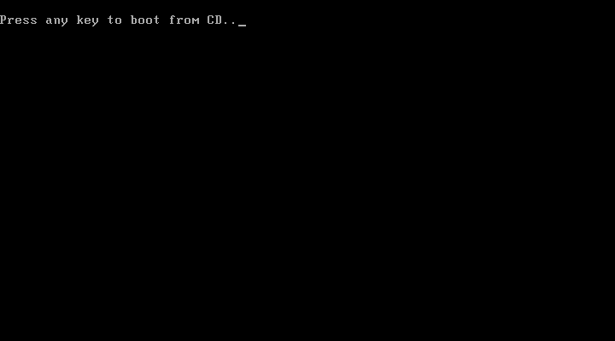  
      
    Your result should be the blue screen showing **Microsoft Server Operating System Setup**.  
      
    Graphical user interface, text, application

    Description automatically generated
12. Once you are at the blue screen to select language, time and keyboard input we will begin the installation.
    1. Language To Install: **English (United States)**
    2. Time and currency format: **English (United States)**
    3. Keyboard or input method: **US**
    4. Then click Next.
13. The **Install Now** button will appear. Click on it.  
      
    Graphical user interface, application, website

    Description automatically generated
14. Setup will begin and this may take some time. You will eventually be prompted with a new window. You will want to select **Windows Server 2022 Standard Evaluation (Desktop Experience)**.  
      
    Graphical user interface, text, application, Teams

    Description automatically generated  
      
    Click on **Next** after you have selected the correct one.
15. Click on the checkbox to accept the Microsoft Software License Terms.  
      
    Graphical user interface, text, application

    Description automatically generated  
      
    Click on **Next** after checking the box to agree to the EULA.
16. For the **What Type of Installation Do You Want** screen, click on **Custom: Install Microsoft Server Operating System only (Advanced)**  
      
    Graphical user interface, text, application, email

    Description automatically generated
17. For the **Where do you want to install the operating system** screen, select **Drive 0 Unallocated Space**; and then click **Next**.  
      
    Graphical user interface, text, application

    Description automatically generated
18. Windows will now begin installing. Be patient, depending on your system this can take a while. If you are running an SSD, it should take only a few minutes.  
      
    Graphical user interface, text, application

    Description automatically generated
19. Eventually, it will complete and reboot on it’s own. Please be patient as this may take more time. When it fully comes back up from the reboot, you will be prompted with a Blue screen called **Customize Settings**. Enter in a decent password that you will remember to set for the Administrator account… and then click **Finish**.  
      
    Graphical user interface, application

    Description automatically generated
20. Once you reach the Windows *Ctrl+Alt+Delete* screen your installation as finished. To log in, most Hyper-Visors offer a button that will allow you to send a CTRL+ALT+DEL to your virtual machine. For VMware it is on the top-right of the console web browser.   
      
    
21. Enter the password you just set and press enter.  
      
    A picture containing text, nature, night sky

    Description automatically generated
22. Wait a moment at the Desktop and don’t do anything. You want to wait for the blue pop out to come about from the right-side of the screen. It will be regarding Networks. Click **Yes** when it appears. (This just makes it easier to transfer files in if you need from other VMs or other physical devices on your network)  
      
    Graphical user interface, text, application

    Description automatically generated
23. Now you are fully logged in and complete with this lab! Note to VMWare ESXi users, you will need to install VMWare tools to resize the screen (and other features as well). Oracle VirtualBox users will need a similar tool that is available with the VirtualBox program. Make sure to also enable Remote Desktop connections as well, it is disabled by default.